Bad segmentation research:

No 4:

Lots of noise

Not full segmentataion

Order of pictures: [true label, predict, predict with clean of 30px]

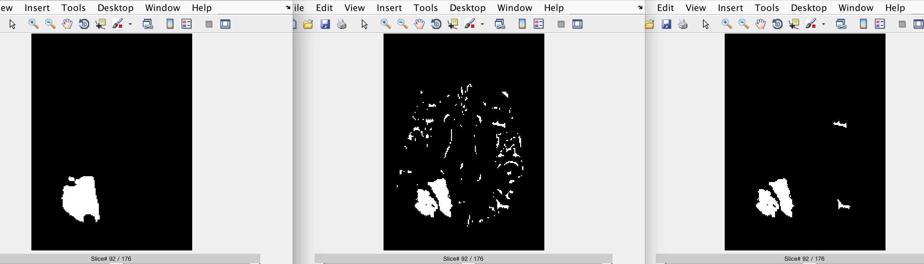

the clean up makes us loss the edges of the segmentation

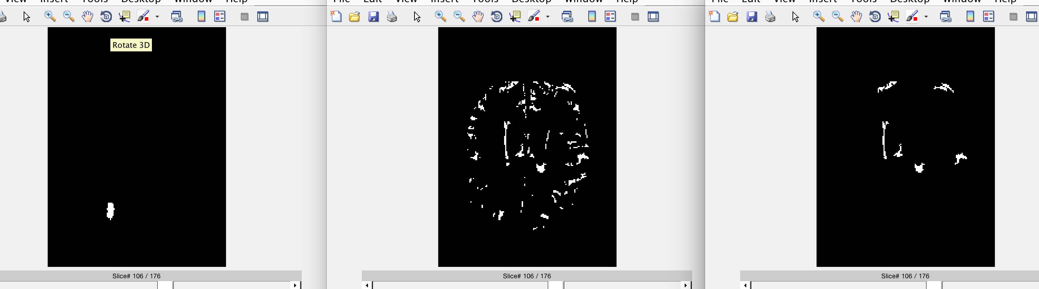

no7:

noise

holes in the segmented tumor

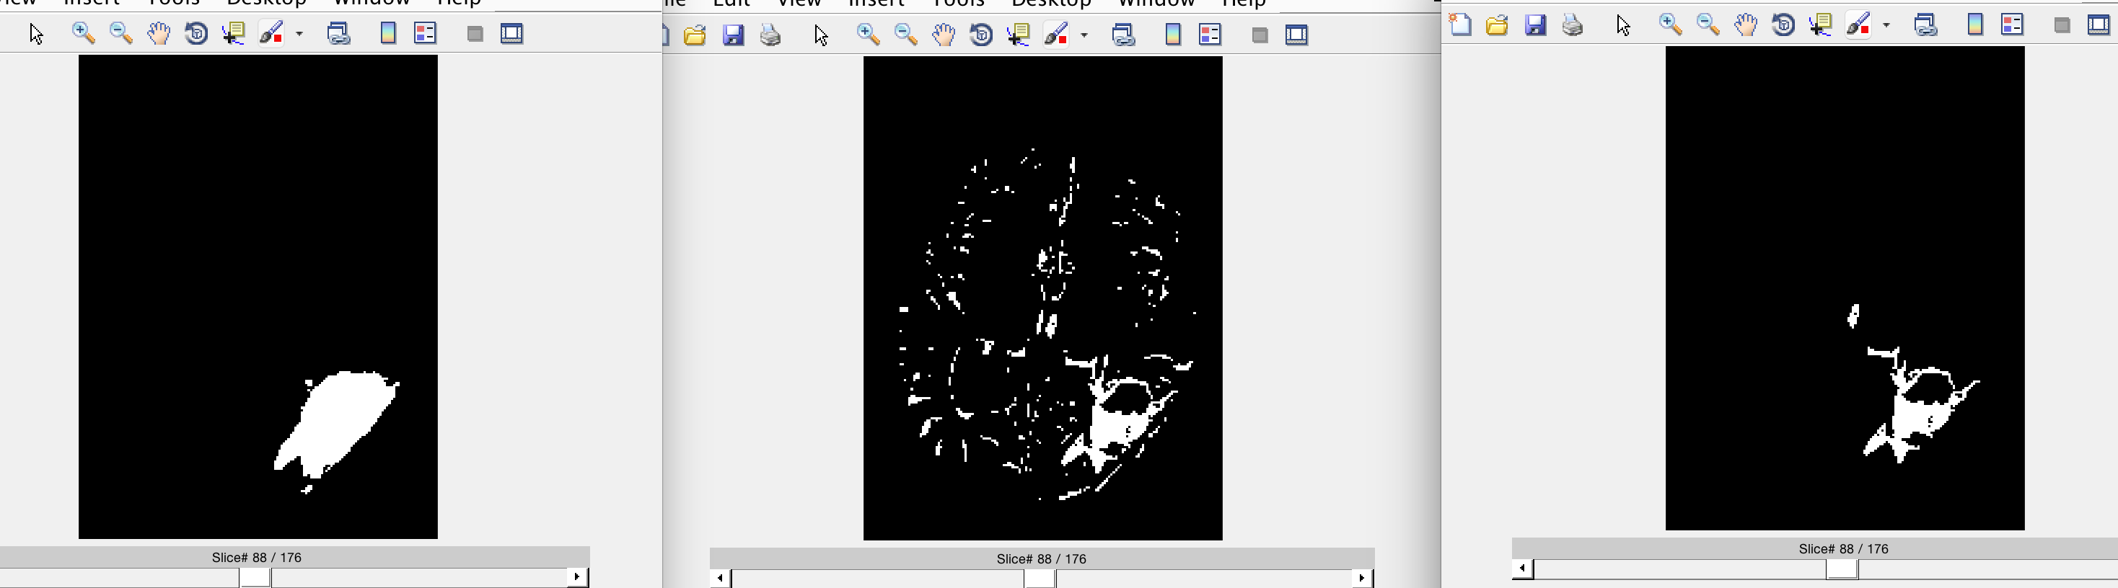

t2 image:

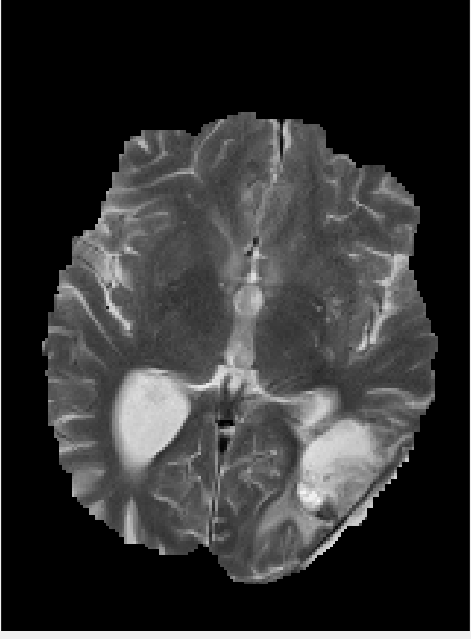

at the edge of the tumor maybe a label mistake ?

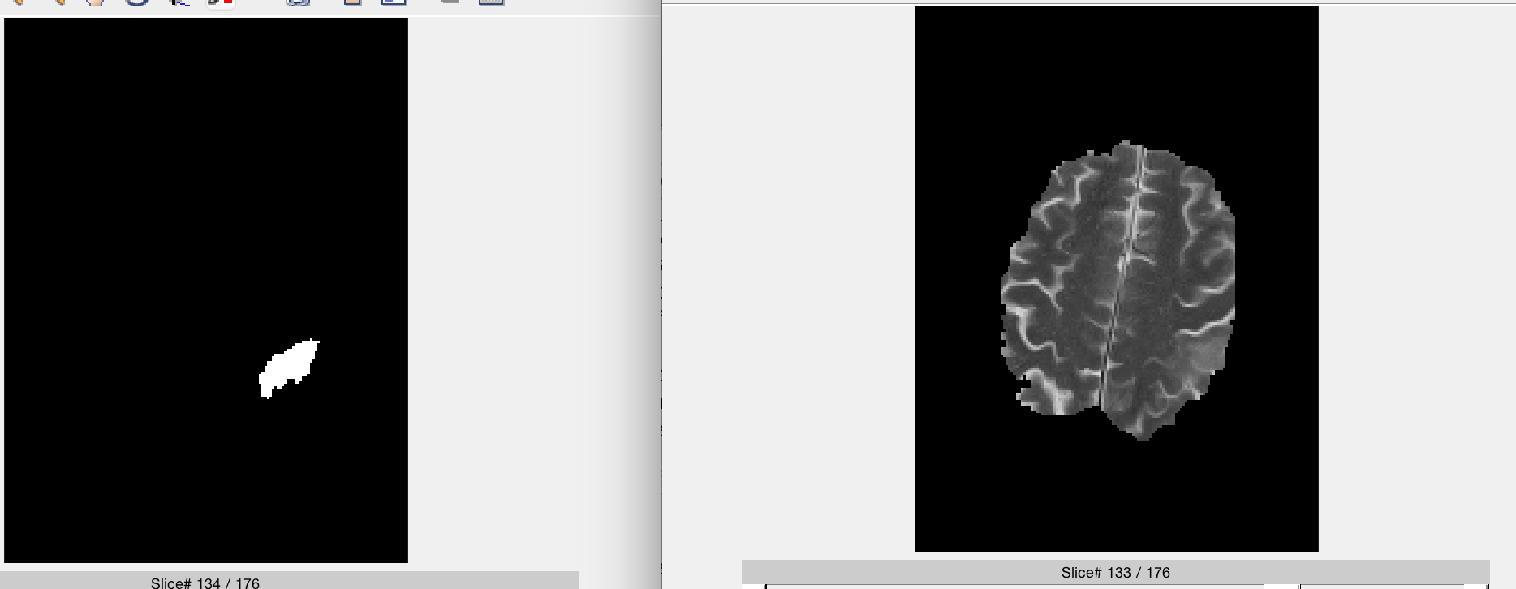

no8

holes and cracks in the segmentation

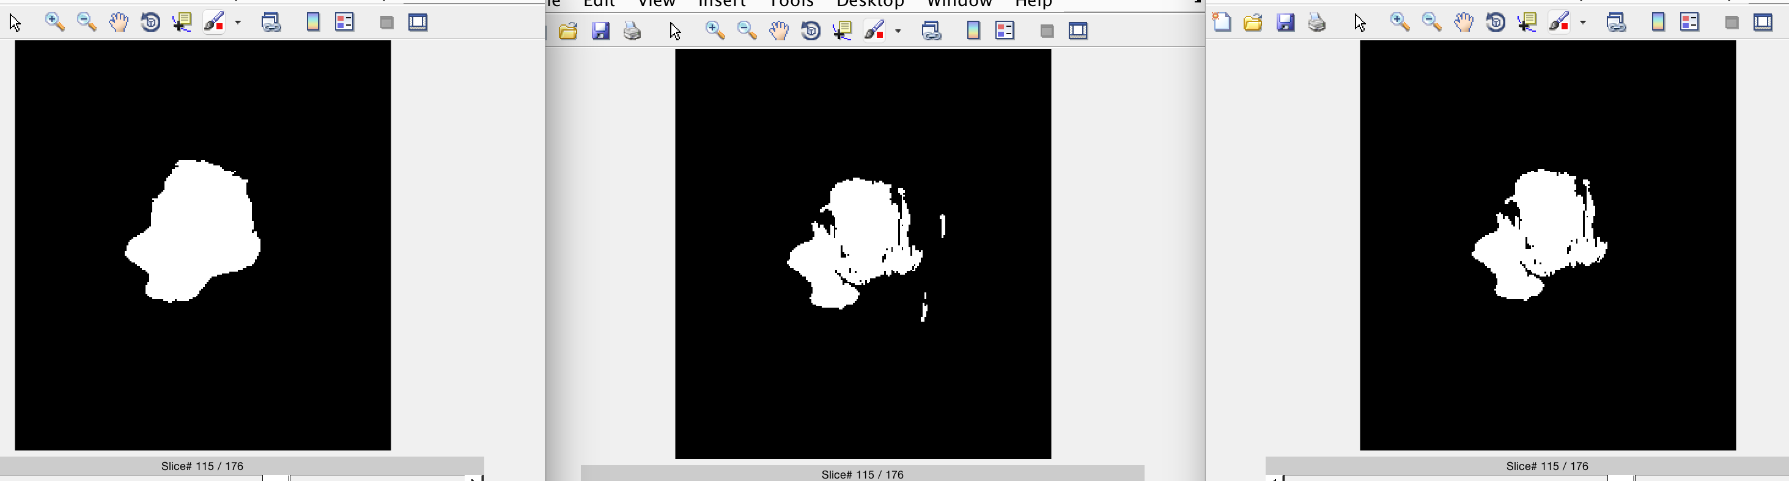

bad segmentation at the edges – small tumor area

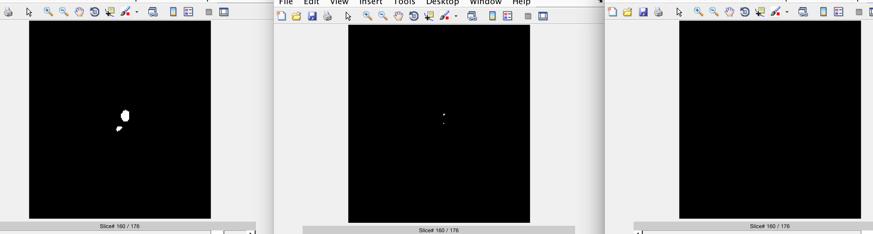

no12 is a reallu hard example I think we should exclude it.

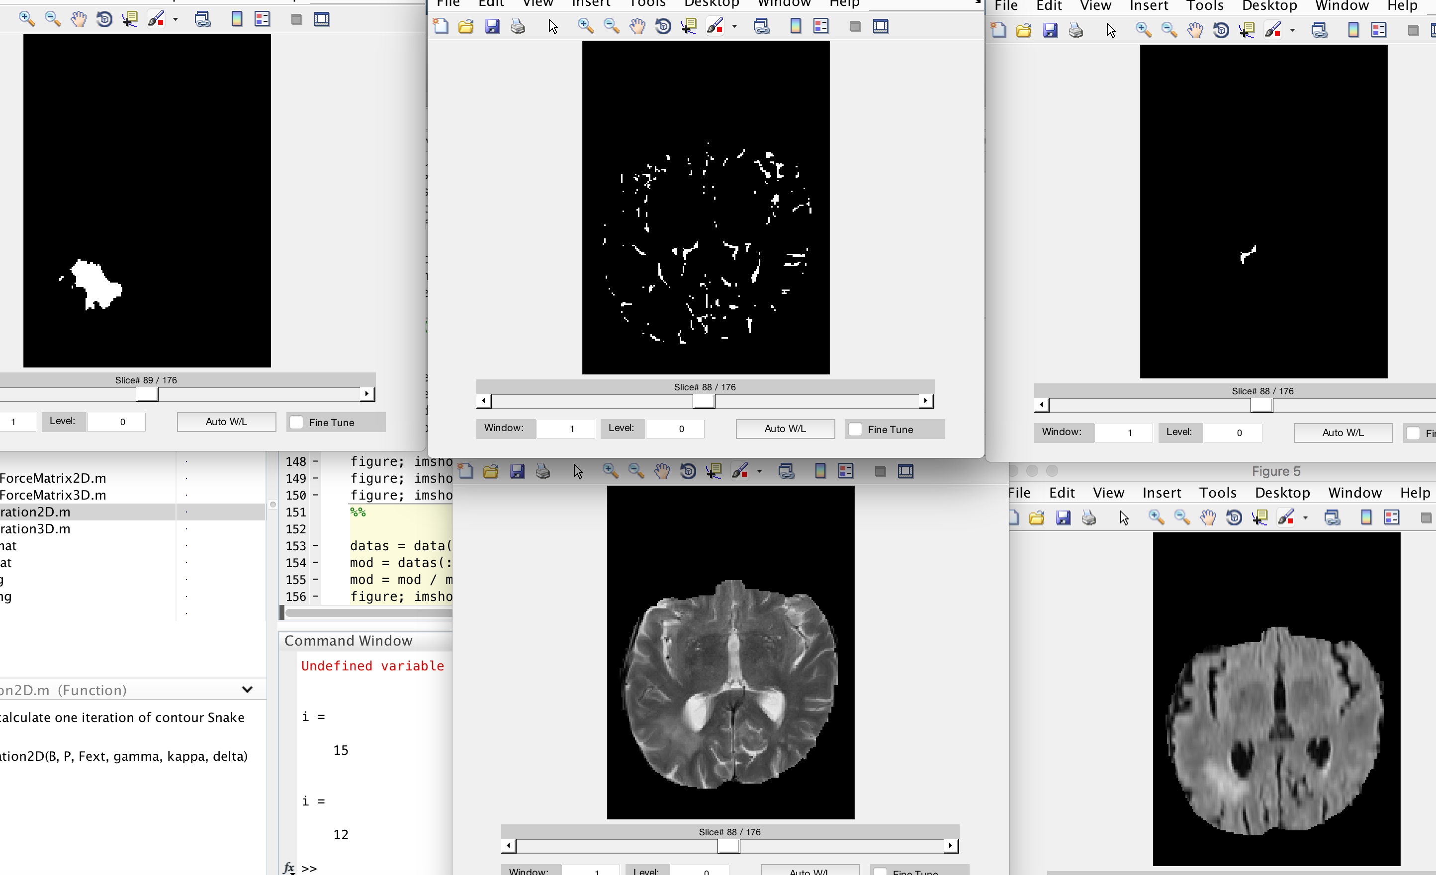

no14

missing major part of the tumor !

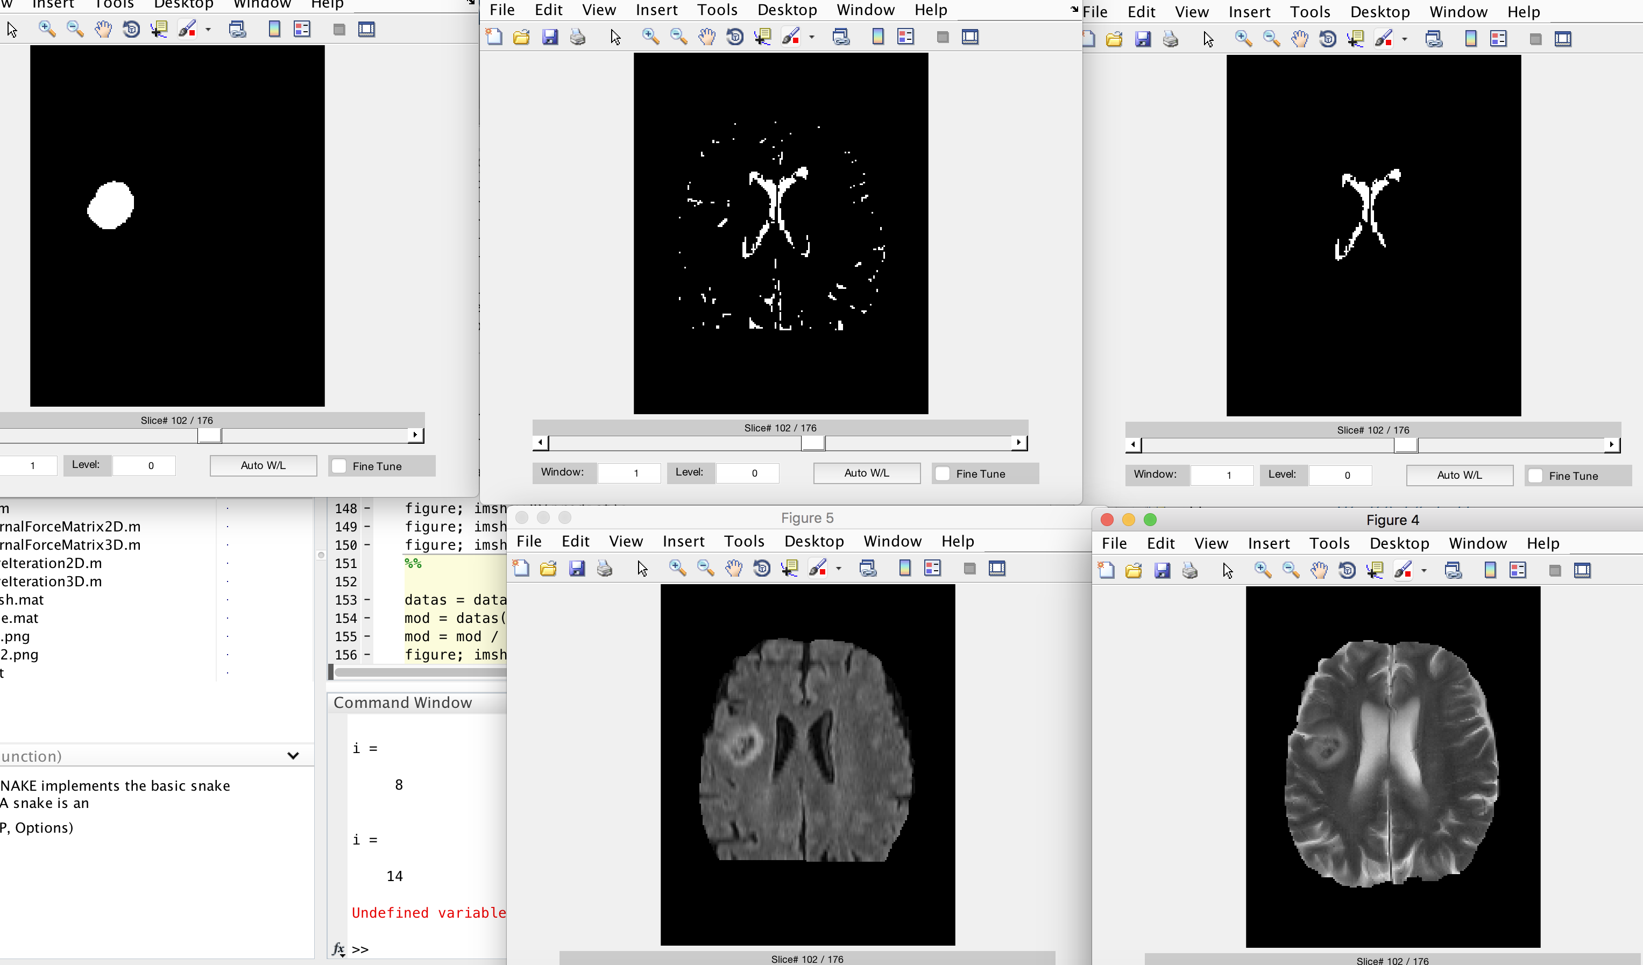

no15

bad segmentaion – recognize tumor when there isn’t

